Dialogue Tree Editor

**Opening The Editor Window 1**

**Creating Dialogue Items (Scriptable Objects) 1**

**Creating And Connecting Nodes 2**

Creating a Node 2

Connecting Nodes 3

**Saving and Loading Files 3**

# Opening The Editor Window

* The editor window is located in the path > Window > Tools > Dialogue Tree Maker as shown.
* When opened you will see a green graph window like the one below, which you can drag around the screen and minimise/maximize as you wish.
* You can move around the graph screen by holding down LMB in the graph area and moving the mouse around. 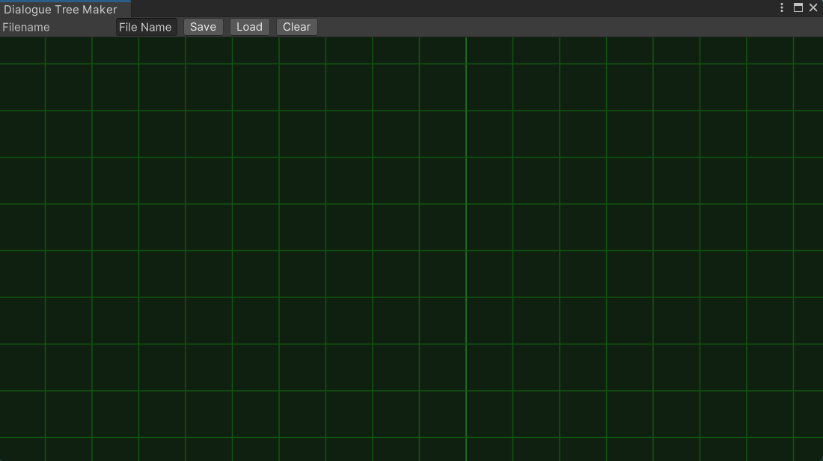

# Creating Dialogue Items (Scriptable Objects)

* The Dialogue tree system uses a type of scriptable object called a Dialogue Item to work
* In order to create a Dialogue Item, right click anywhere within the project window and select Create>ScriptableObjects>DialogueItem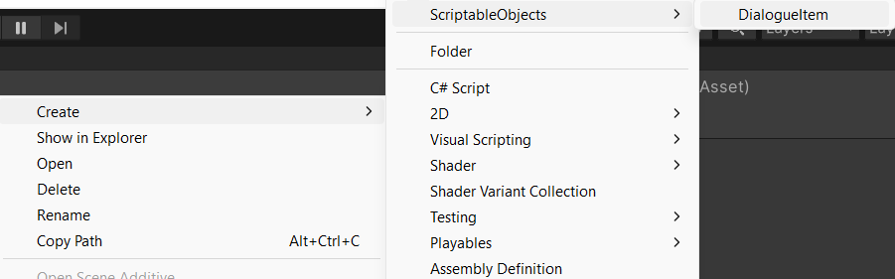
* Each Dialogue Item contains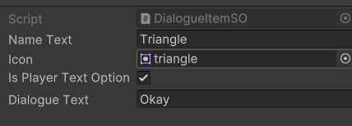
  + Name
  + Icon Image
  + bool to check if the Player or an NPC speaking
  + the dialogue text itself (which is also editable in the editor window)

# Creating And Connecting Nodes

## Creating a Node

* You can create a node by right clicking anywhere within the editor window and pressing Add Dialogue Node
* An empty node will appear
* You can select any Dialogue Item you have made from the Dialogue Item field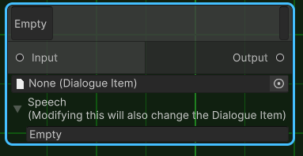
* You can modify the Dialogue Item’s speech text within the speech field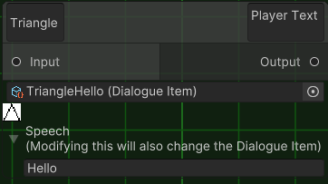
* Modifying the Speech field of a Dialogue Item you have selected will also change the contents of the Dialogue Item
* The text at the top shows the name text and whether it is a player text option or an NPC speaking

## Connecting Nodes

* Any Output port can be dragged into any Input port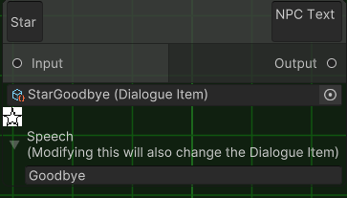
* In order to implement the dialogue system more easily you might want to…
  + Make sure to always have exactly one node without an Input port; this will be considered the root node and if there are none or there are multiple then it will not function as expected
  + Make sure to order the nodes as NPC > Player > NPC > Player > NPC etc

# Saving and Loading Files

* The Filename Text Field within the toolbar can be modified to whatever you would like to name your file.
* Save will open file manager where you can choose a location to save your file. This will save the current contents of the editor window
* Load will open file manager where you can choose a file you have previously saved to load into the editor window. Beware that if you press load (regardless of if you select a file) it will clear whatever is currently in the editor window
* Clear removes anything that is currently in the editor window